FINAL REPORT

Date: 12/28/09
Agreement Number: 08HQAG0063
Project title: Building Stewardship Capacity for Structures and Transportation Geodata within the Iowa Geospatial Infrastructure
Organization:
Iowa Geographic Information Council, 291 Durham, Ames, IA 50011, http://www.iowagic.org/
Principal Investigator:
James D. Giglierano, Iowa DNR, 109 Trowbridge Hall, Iowa City, IA 52242
Collaborating Organizations:
Iowa State University, GIS Support and Research Facility
Kevin Kane, 291 Durham, Ames, IA 50011, http://www.gis.iastate.edu
USGS Geospatial (State) Liaison: Robert Lemen, 573-308-3736, rlemen@usgs.gov
Data themes: Building structures and transportation road centerlines
Executive Summary
The 2008 Iowa Structures and Transportation CAP grant was partially successful in attaining its goals. Problems with the state’s lidar acquisition prevented the timely extraction of building footprint data from lidar. Three counties of building footprint data are in review and will be available shortly. IDOT provided statewide road centerline data but was unable to make public a WFS to provide updates due to security concerns with its server. Project partner Iowa State University GIS Support and Research Facility completed a hardware upgrade for servers housing the statewide data sets used in a wide variety of applications, including this project. They also successfully developed an online Structure Maintenance Tool (SMT) that will allow smaller local governments to update the structure footprint data layer through online editing polygon features and attributes. Stewardship agreements with local governments for maintenance of the structure layer were deferred to allow the state’s $1.3 Geocoding Project to develop comprehensive data sharing and maintenance agreements that include all Iowa Geospatial Infrastructure framework layers, including structures.

Project Narrative
A. Describe the project; its tasks, highlights, challenges, and accomplishments.
The 2008 CAP project’s main goal was to develop processes for providing structures and transportation data from Iowa to the NSDI and maintain them over the long term. Project tasks included:

Task 1 - the Iowa Geographic Information Council will seek agreements for the stewardship of a structures GIS framework layer by local governments and transportation GIS framework layer by the Iowa DOT.
This project did not develop any agreements for structures stewardship because this work is being taken over by the state of Iowa’s $1.3M Statewide Geocoding Project, which commenced July 1, 2009, and will continue over the next 4 years. It was decided that the task of developing agreements would be better accomplished by the larger Geocoding project in conjunction with other statewide projects, and that any initial agreements for structures would be premature and have to be redone. Ultimately, we are seeking comprehensive IGI data sharing and stewardship agreements between IGI partners (including federal, state, local and private) and data producers that will include all framework layers: orthophotos, control points, administrative boundaries, cadastral, elevation, hydrography, transportation as well as structures. The Geocoding project is in the process of developing more comprehensive contacts with various local government entities and their data contractors that maintain and use high-quality GIS data, especially in regard to address points and road centerlines available from local E911 PSAPs. The state homeland security division is in the process of developing an RFP for contractors to supply components of the Next Generation 911 system, which will include maintenance of high-quality GIS data needed for tagging IP based 911 calls (voice, text, data and video). The proposed NG911 system will have to address maintenance of the GIS data, including address points and road centerline address ranges on a statewide, centralized basis. Combined with building structure footprints provided by local entities, it is believed this system will have the best chance of successfully maintaining these three framework data layers for the long term..

The Iowa DOT, Office of Transportation Data has agreed to provide its linear referencing system based road centerline file and other transportation layers on an annual basis.

Task 2 – Develop GIS technical infrastructure to support the maintenance and stewardship of the structure data layer by developing a web editing service. This task was accomplished by the Iowa State University partner GIS Support and Research Facility (GISSRF) using ArcGIS server technology. GISSRF set up an ArcGIS Server application to perform online editing of building footprints (called the Structure Maintenance Tool or SMT). This password accessible application is intended for jurisdictions that do not have extensive in-house GIS capabilities or rapidly changing urban settings. In Iowa, rapidly changing areas usually have good GIS programs and updates to the structures database will be handled through the exchange of files. The SMT currently has pilot structure data derived from lidar for Polk and Story Counties, as well as current NAIP background imagery. GISSRF has produced two documents for this application – one describing how the application was set up using ArcGIS Server 3.0 and a tutorial. The set-up and tutorial documents are available on the IGIC web site:
http://www.iowagic.org/igi/structures-and-transportation-cap-grant-2008

Figure 1 – screenshot of Structure Maintenance Tool showing tools for editing polygons
and attributes.
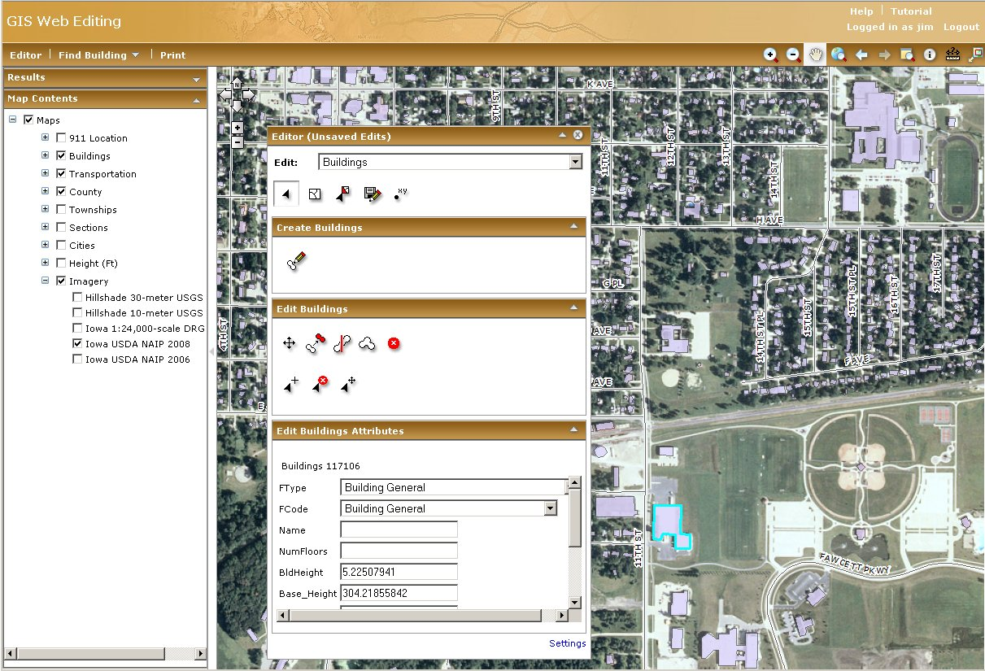
Task 3 – Upgrade critical orthoimagery server at Iowa State University used in a variety of base mapping application and data development processes throughout the state (including this project). This task was accomplished by the ISU GISSRF. The Iowa Geographic Map Server (aka Iowa Ortho Server - http://ortho.gis.iastate.edu/) has been in operation since 1999 and was a cooperative development of the USDA Natural Resources Conservation Service and the Massachusetts Institute of Technology. The Iowa Ortho Server provides online access and viewing of several statewide raster layers including USGS funded orthophotos and DRG topographic map rasters, It has 2004-2009 USDA National Aerial Imagery Program data for Iowa as well as 2’ 4-band orthoimagery collected under the current statewide ortho program. The complex of servers and attached storage that make up the ortho imagery services critical to a variety of base mapping applications and data development processes was upgraded with more robust hardware and the storage space doubled to roughly 14 terrabytes. This new space will allow for easy access to LiDAR data as it is acquired, higher resolution aerial photography, other supporting data, and the output of the LiDAR application built to develop the NSDI structures database for Iowa. The high-end server is able to use specialized GIS software to provide the data more reliably and quickly than the previous arrangement.

Imagery stored on the ISU server is directly used in the SMT application.

Task 4 – Develop of a extraction and translation service to automate transportation data from from IDOT’s Linear Referencing System and GIMS database and store it in a centralized road centerline layer. This task was partially successful in that a road centerline layer from LRS/GIMS will be available through the IGI portal by the end of January 2010. This layer will be updated yearly, but not through an automated WFS process. DOT developed a WFS for internal DOT use, but was unsuccessful in getting a public deployment due to security concerns over a reverse proxy needed by the public service. The service is operating internally, and will be hopefully deployed publicly later in the spring of 2010 or FY 2011.

Approaches for participating in the NSDI: Iowa is a very GIS data rich state, with 75% of counties having some sort of GIS program, a statewide 2’ 4-band leaf-off orthoimagery project and a statewide 1 meter lidar project. The USGS state geospatial liaison for Iowa has played a very central role in helping coordinate these projects and injecting funding for critical pieces. That being said, Iowa has had little centralized GIS coordination over the past 20 years, with no state GIO or coordinator currently and a weak volunteer-led geographic council that only meets quarterly. With the state’s economy and poor budget outlook, there doesn’t appear much likelihood for any state funding for the long term staffing needed to run IGI. Using the IGI business plan and return on investment analysis from our 2007 50 States CAP Grant, we are proceeding to build key IGI components using project funding. So far this approach has resulted in $650k for the first half of the statewide geocoding project, which we are using to leverage other framework data layers into products needed by local GIS programs, in exchange for access to local GIS data. Obtaining the good will of local data producers is critical to IGI, NSDI and TNM.

Table 1 shows a comparison of TNM US Topo base layers and IGI framework layers. US Topo base layers were taken from the draft specification v0.5.10 document, and shows which layers and sources are currently being used or not. IGI framework layers are categorized as best available and future. Many of the future IGI layers will be collected from local sources and merged into statewide coverages by either a state and/or county GIS service bureau. There are two proposals pending to fund parts of a county and a state GIS service bureau.
Table 1 - Comparison of TNM/US Topo base layers to Iowa Geospatial Infrastructure framework layers.
US Topo  v0.5.10  base layers | included - source | not included | IGI framework layers | best available - source | future - source | funding available - years to complete
orthoimage base | 1m color leaf on - NAIP |  | orthoimagery | 1m color leaf on - NAIP  2' 4-band leaf off - state | 1' and 6" color - IFTN | $1.5M for 2’  ARRA grant pending for higher resolution
transportation | roads - census  airports - GNIS | rails, trails, other transportation features | transportation | roads, rails, airports - IDOT  trails - IDNR | private roads – counties and cities | Possibly NG911?
boundaries | national, 1000 m USNG | state, county, PLSS | boundaries | municipal - IDOT  county - IDNR | municipal, county - counties | none
structures | schools and hospitals - GNIS | other large structures (from HSIP?) | structures |  | building footprints - state | $1.3M geocoding project - 4 yrs
geographic names | populated and unpop places, natural features - GNIS  hydro - NHD | other features | no plans |  |  | none
elevation | 5', 10', 20' contours - NED | spot elevations | elevation | 10 m NED | 1 m lidar bare earth and 2’ contours - state | $4.3 M - 2 yrs
hydrography | NHD 24k hi-resolution |  | hydrography | NWI 24k update - IDNR | local resolution stream centerlines from lidar - IDNR | none
control |  | benchmarks | Geodetic control | NGS, county GPS monuments |  | intern - 2 yrs
land cover |  | wetlands, urban areas, forest | land cover (not an IGI framework layer) | 15 m 2002 landsat land cover - IDNR | 1 m land cover - IDNR | DNR internal - 3 yrs
 |  |  | cadastral | PLSS - IDNR | PLSS, parcels - counties | none
 |  |  | address points | driveway points - county E911 | building points and footprints - state | $1.3M geocoding project - 4 yrs

B. Describe the data content provided to The National Map.
For this project the Iowa DOT, Office of Transportation Data produced a 2009 transportation base map geodatabase containing several layers. This public data is available to The National Map. The Office of Transportation Data is the data custodian for road centerline GIS data representing all federal, state, county and municipality maintained roads in the state. DOT collects new road graphics and tabular attributes for secondary roads from county engineers and from the 100 largest cities every year. On a four year cycle it collects city road information from the remaining 847 smaller municipalities in the state. Data collected from local governments can either be in GIS, CAD or paper form, which are used along with aerial photography to update the GIS road centerline data. DOT does not maintain private roads unless that information is supplied by the local government. Other DOT base map layers include airports and mile markers.

DOT also collects legal descriptions, plats and surveys of changes to municipal corporate boundaries from the state’s City Development Board, which handles all annexation requests in the state. With this information DOT maintains GIS data for city boundaries with yearly updates. This layer is also included in the 2009 transportation base map geodatabase. These data layers will be available before January 30, 2010 through the IGI portal.

Despite difficulties with the lidar data, there were three counties of structure footprints and address points produced during the project. These pilot data products use the Structures Best Practices Model and the NENA/URISA draft address standard. These data products are undergoing internal review and will be made available for external review by January 30, 2010, through the IGI portal. Upon final approval, these data files will be made publicly available with metadata registered through the Iowa Geospatial Data Clearinghouse (http://www.iowagis.org/), which is an NSDI clearinghouse node. Additional counties are in progress and will be available by July 1, 2010.

This CAP project intended to derive structure footprints using statewide lidar data collected through USGS CSC-2 contract vehicle, task order #01014C0050. Difficulties encountered during the project have been numerous, not the least of which was the lack of usable lidar data.
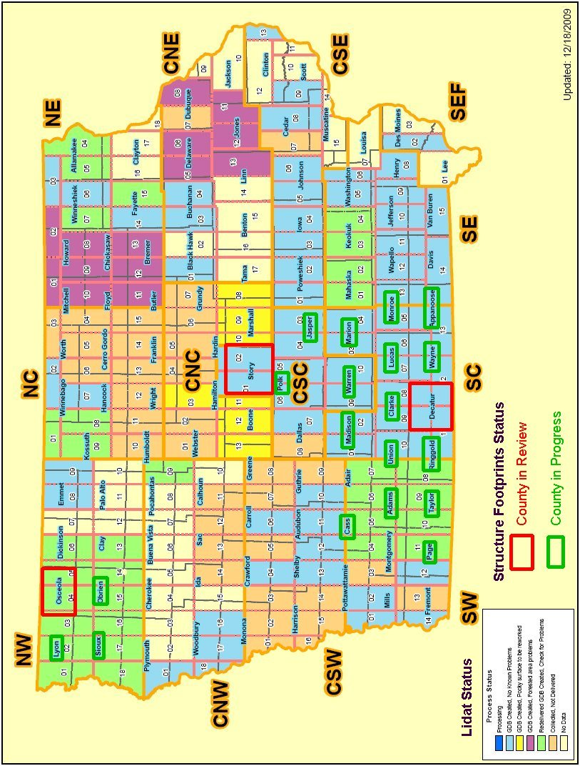
Figure 2 – Status of extracting structure footprints from lidar, overlaid on lidar delivery status as of 12/18/2009.
While more than half of the state has been collected to date, less than half has been delivered and many tiles have processing issues including noise (striping and pock marks), missing data points, missing classifications and missing metadata. Additional difficulties have been encountered with accurately extracting building footprints. While large buildings are extracted cleanly, houses in older neighborhoods with tall trees are problematic, needing manual extraction and/or editing. Automating this process has not been possible, so current plans are to extract a “cartographic product” usable above a specified scale (probably 1:12,000), and possibly edit building polygons into a cleaner form as part of the statewide geocoding project.

Our follow-on plans for the structures data is to develop this framework layer as a part of the state's geocoding project which focuses on a statewide address point layer and geocoding service. The geocoding project will complete the address point and structures layer over the next 4-5 years. The initial 2-year project will complete 30-50 counties, with the remainder finishing up over the next 2-3 years.
C. Describe the operational capability to maintain and update data through periodic updates of data made available to The National Map.
It is our intent to use the ArcGIS server-based structure maintenance tool (SMT) developed by this project to maintain a centralized structures polygon layer and address point layer for the state. The public rollout for this service will be July 1, 2010. As the state develops its Next Generation 911 system over the next several years, the location and custodian organization will likely change. Data files will continue to be available through the IGI portal and other traditional Iowa data nodes described below.

The operational capability for periodic updates will continue for specific framework and other GIS layers at the following data repository nodes in Iowa:
- DOT - transportation data -http://www.iowadot.gov/gis/default.htm
- DNR - natural resource data - http://www.igsb.uiowa.edu/webapps/nrgislibx/
- ISU Ortho Server – statewide raster data - http://ortho.gis.iastate.edu/
- Iowa County Information technology Group’s (ICIT) Data Repository - GIS vector data created by local governments - https://www.iowagisdata.org/gisdr

The DNR NRGIS library has been providing free online GIS data in the UTM projection (with FGDC metadata) to the public since 1994. While this service will continue indefinitely, DNR's site can not provide the same data sets in multiple formats and/or projections. Using hardware purchased through this CAP project, the ISU GISSRF will provide a new data node for strictly IGI framework data products, including structures, centerlines, and orthoimagery from local sources in multiple formats and projections typically used by local entities.

In the near future, there are plans for providing basic GIS framework layers using web services (WMS, WCS, WFS). Orthoimagery is already being delivered via WMS by ISU GISSRF (http://ortho.gis.iastate.edu/tools.html). Using ArcGIS Server map caches, the Iowa Basemap will feature more than 20 different vector datasets that are used to create a common reference map reusable by other state agencies. The Iowa Basemap, initiated by the Iowa DNR, will eventually be a collaborative effort by multiple state agencies including the Iowa DOT and Iowa Homeland Security and Emergency Management Division. State agency data stewards will contribute framework and other data along with a standardized symbology to the Iowa Basemap. The Iowa Basemap will be available as a shared web service to other agencies. Updates are planned on a yearly or semi-annual basis once the service is established.

D. Discuss the issues, difficulties, and challenges (technical, institutional, and organizational) that were encountered.
We were invited to participate with the USGS state geospatial liaisons last June in Ft. Collins at a central region coordination meeting. This was a very good meeting and it should be held again at least every other year. What was most encouraging to see from the federal side was the solid direction that USGS mapping programs were taking with a renewed commitment to The National Map and the sister programs that support it. For a long time this was not the case and federal mapping was drifting along with no real direction.

What was most lacking about the TNM presentation at the Ft. Collins meeting was an assessment of the costs of a fully functioning program and the societal benefits of the product itself. Comments were made about the 11 to 1 leveraging of state/local funds to federal funds. While on paper this sounds good, it hides the fact that the state/local side might consist of very little actual funding - definitely not enough to sustain programs like TNM that are relying on the state/local component for maintaining data content and currency. While ambitious technical goals were set out for the 3-year PDF cycle, no mention was made about the cost of getting there, especially for future products that will include all the basic data layers needed to recreate basic topographic maps. As a state person, the implication is that USGS assumes the resources will be there on the state/local side, but there is no recognition that this requires lots of planning and a realistic assessment of available resources to do the intended job.

During one of the presentations, a slide was shown that listed a large number of topographic map stakeholders, but no data indicating how beneficial the maps would be to these stakeholders, or to society in general in financial terms. This is an important part of the overall analysis and we urge USGS to calculate return on investment for the TNM products. This analysis should be part of a TNM business plan, done in partnership with the state/local data providers. States are being asked to complete business plans for state spatial data infrastructures, so doesn't it make sense that TNM should do one as well? This idea should be extended to the NSDI as a whole. It has been our experience that this will help with obtaining additional funding for mapping programs.

This brings up one final comment: on the home page of The National Map, there is a introductory paragraph that states "The National Map is a significant contribution to the NSDI". It has never been clear how the two are related: is TNM the map product of NSDI or are they complimentary but parallel programs? Nowhere is this confusion more evident than in data standards, with FGDC meticulously working for years on data standards for all kinds of GIS data, while TNM pushes the best practices models on their web sites. This was a very confusing issue during this project for both structures and transportation layers. Everyone is likely struggling with the issue of which standard to use or best practice model.

E. Describe your relationship and issues with the USGS.
Given the above comments about a TNM business plan, our follow on efforts shall include meetings with our USGS geospatial state liaison to develop an outline of how data will get into TNM from Iowa, including comparing likely schedules for TNM and IGI. We have a 10 year IGI business plan to build all the framework data layers for Iowa, but how does that fit in with the various 3-year PDF cycles for TNM? Where are there overlaps and where will there be gaps, both in terms of coverage and resources? There are several opportunities for substantial cooperation.

Iowa DNR has recently completed a data stewardship agreement with our state liaison for the National Hydrography Dataset (see attached file). We are trying to create a new stream centerline file derived from our new statewide lidar data at local scale (probably 1:4,800). Our local WRD office is completing its STREAMSTATS analysis using the hi-resolution NHD available in the national database. Corrections made to the hi-res NHD are not being stored back in the national database. We have provided our WRD office with 1 meter bare earth lidar DEMs for one 8-digit HUC to test stream extraction procedures developed during their STREAMSTATS analysis. DNR also has update National Wetland Inventory line work and attributes that it would like to conflate with lidar centerlines. We need to work with our state geospatial liaison to try to merge these efforts into a coherent workflow so that no efforts are wasted.

After the great flood of 2008 Iowa has a mandate from its legislature to produce new floodplain maps for the whole state in 5-7 years. With this mandate came $14M in one time funding plus ongoing staff costs for a revitalized floodplain management program. This represents a good opportunity to coordinate and cooperate on base maps for both TNM and floodplain programs. We will be working closely with local governments to include their GIS information as layers in local scale base maps as well.

CAP PROGRAM EVALUATION QUESTIONS
What are the program strengths and weaknesses?
The greatest strength of the program is that it exists and consistently helps move different groups and states in the right general direction. The greatest weakness is not funding, but having an overall TNM or NSDI business plan that everyone can refer to, chart progress and plan cooperative activities over several years rather than just seeing what turns up through a yearly competition. We have found that having a business plan for IGI allows us to more quickly take advantage of unexpected opportunities that arise, as well as plan year to year.

Where does the program make a difference?
For this project, the program got us going in the right direction and helped us leverage additional funding needed to actually create the building structure data. Initially we overestimated how much building structure data we could create as a by-product of another funded project (lidar processing). This led to leveraging additional funding so the job could be done correctly. We now have half of what we need ($650k) to complete the statewide address point and building structure layer, with the expectation of successfully acquiring the rest from the same state technology fund.
What would you recommend doing differently?
One issue that could help both USGS and groups applying for future grants is for USGS to make clearer their goals for each grant category, especially for data centric grants like this one. While developing the proposal for Iowa's application for this grant it was not clear that the USGS wanted actual data that could be included in TNM and not web services such as WMS or in developing technology to update databases online, as we did in this project. We were also not as keenly aware that the program was looking for HSIP data updates. This became clearer during one of the project conference calls. Now that these grants are more closely tied to TNM needs, these requirements should be easier to spot.

